EDWIN Subscriptions Management System User Manual

This document will walk users through the different functions that they can carry out in the EDWIN Subscriptions Management system. Each function is listed below. Click the desired subject to jump to that section.

Site URL: https://edwin.dcnr.pa.gov

CONTENTS
- Registering for New Account
- Logging in
- Editing Company Details
- Adding New Contact
- Granting Existing Contact Access
- Editing Contacts
- Deleting Contacts
- View EDWIN License Details
- Requesting EDWIN License Password
- Submitting Payment
- View Billing Details

Registering for New Account
- Go to https://edwin.dcnr.pa.gov
- Click the “Subscribe” link in the menu bar OR the “Subscribe” button under the Subscribe section.
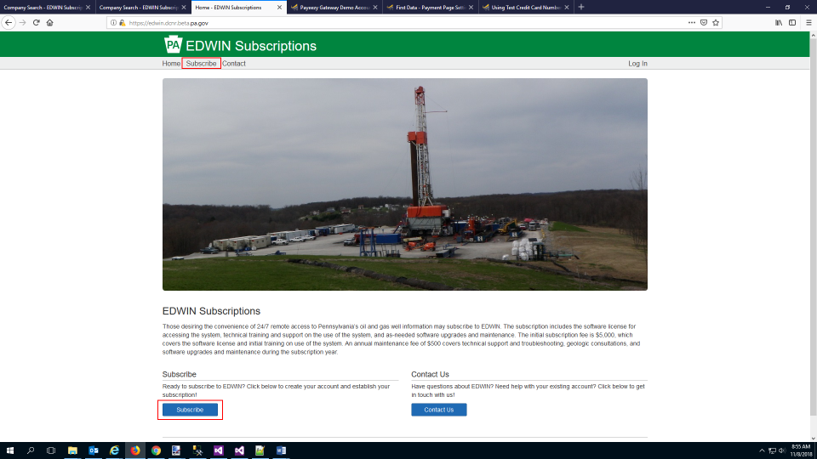
- If you already have a Keystone Login Account, click the “Login” button and go to step 3a. If you need to create a Keystone Login Account, click the “Create” button and go to step 3b.
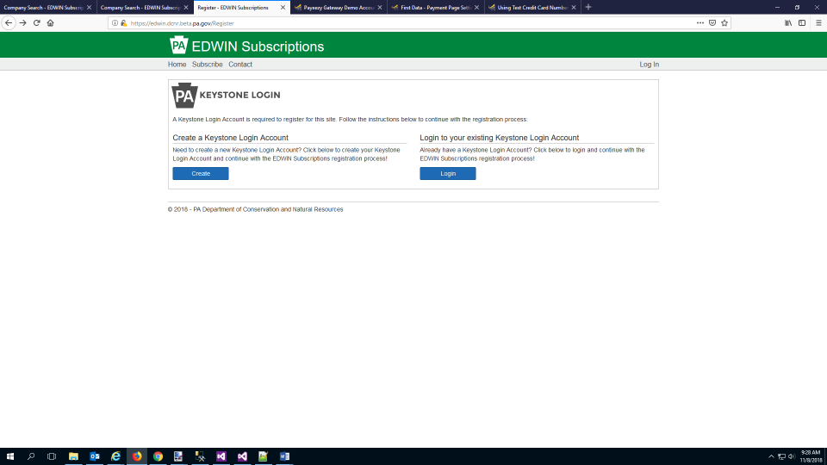
3a. At the Keystone Login Account page log in to your account. After successfully logging in, you will be redirected back to the EDWIN Subscriptions site. Go to step 4.

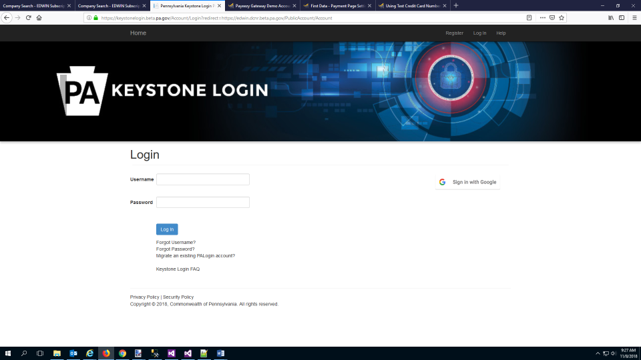
3b. Follow the instructions on the page to create your Keystone Login Account. Go to step 4.
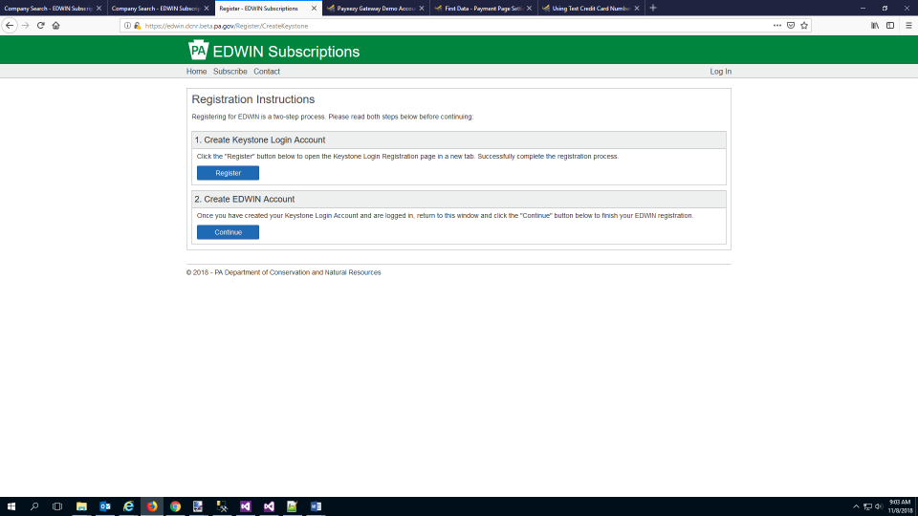

- Enter your company details then click the “Continue” button.
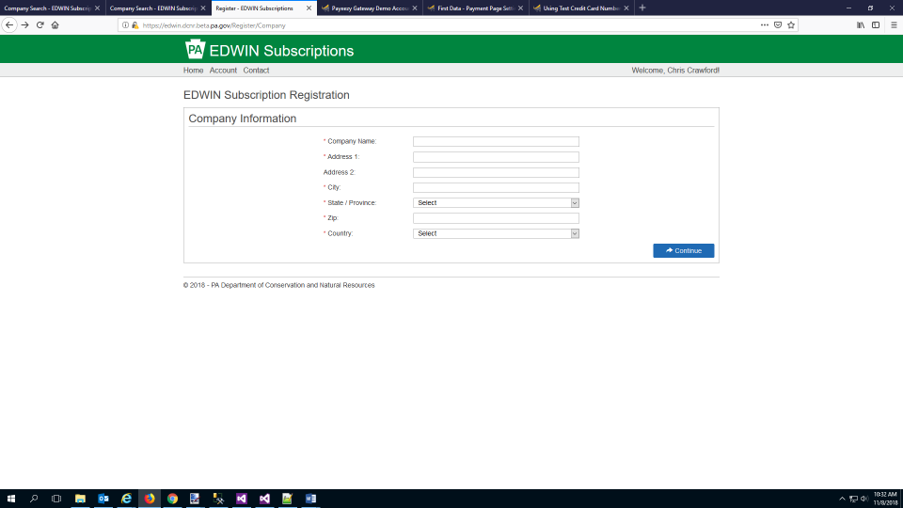
- Enter your contact information. Be sure to enter your correct email address in the email field. Click the “Continue” button.
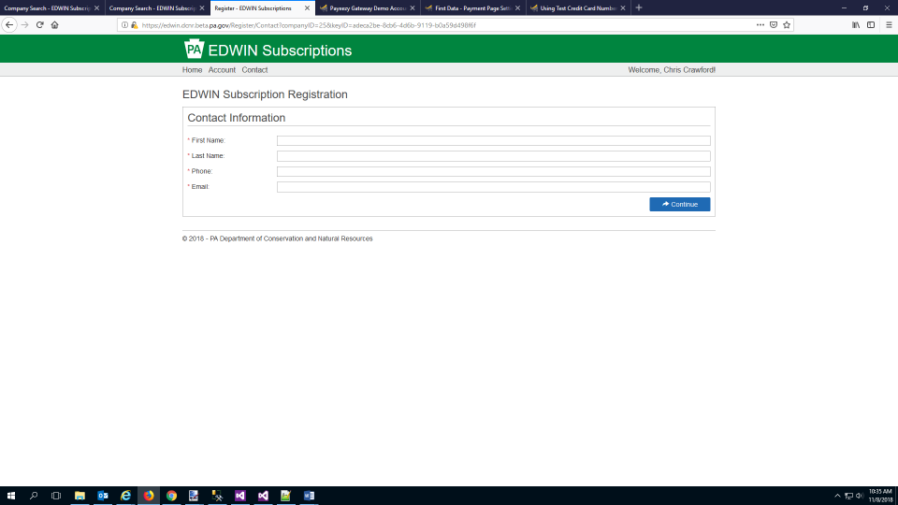

- Your account should be successfully created and saved in the system. You will automatically be redirected to your account page.
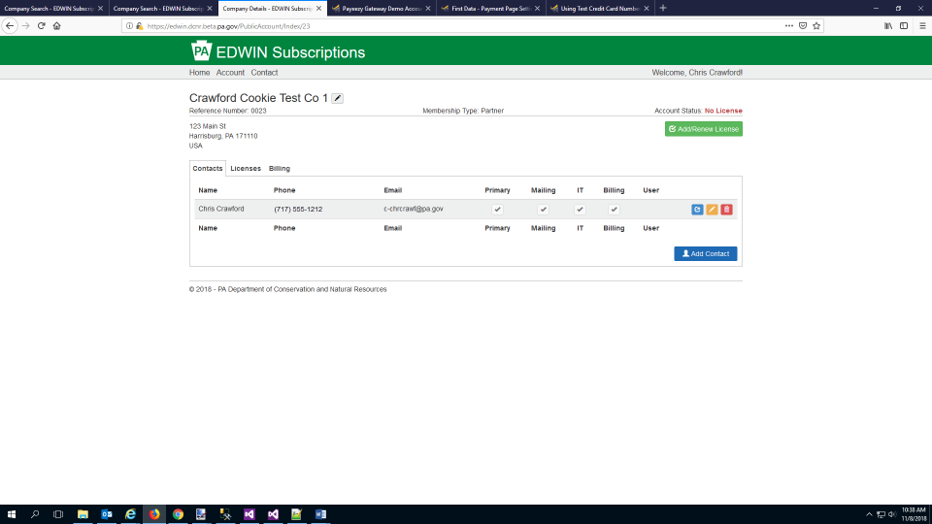

Logging in
1. Go to https://edwin.dcnr.pa.gov and click the “Log in” link in the menu bar.
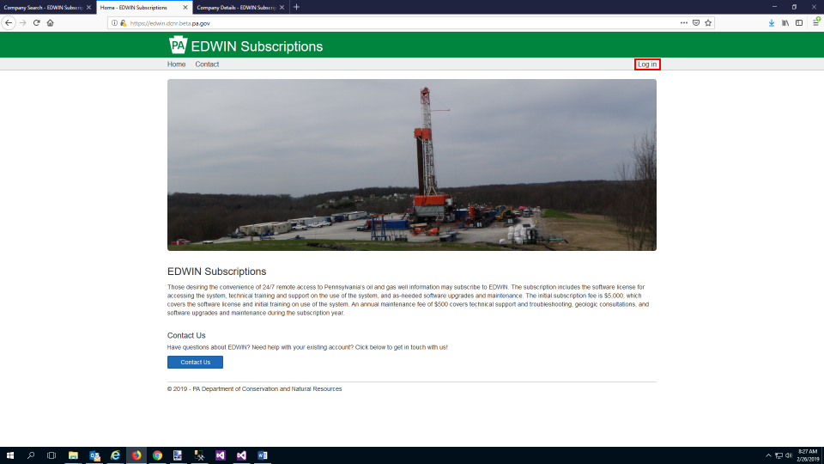
3. Log in to your Keystone Login account.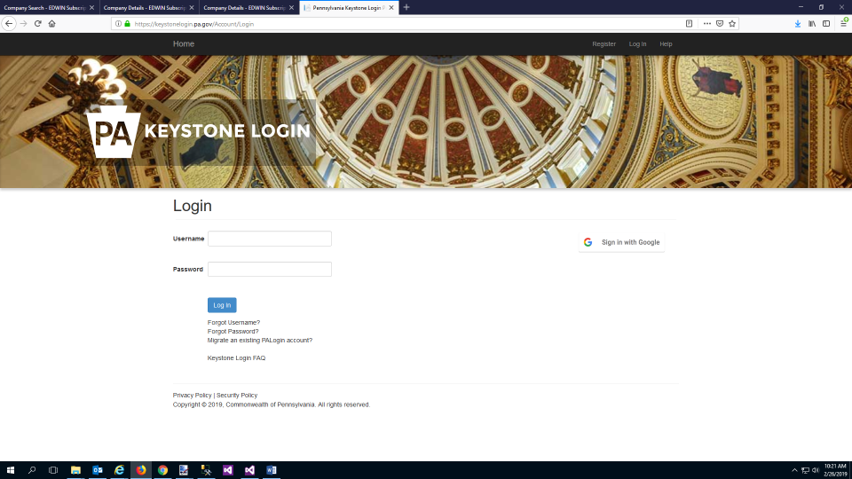
4. You will be automatically sent to your Account page in EDWIN Subscription Management System.
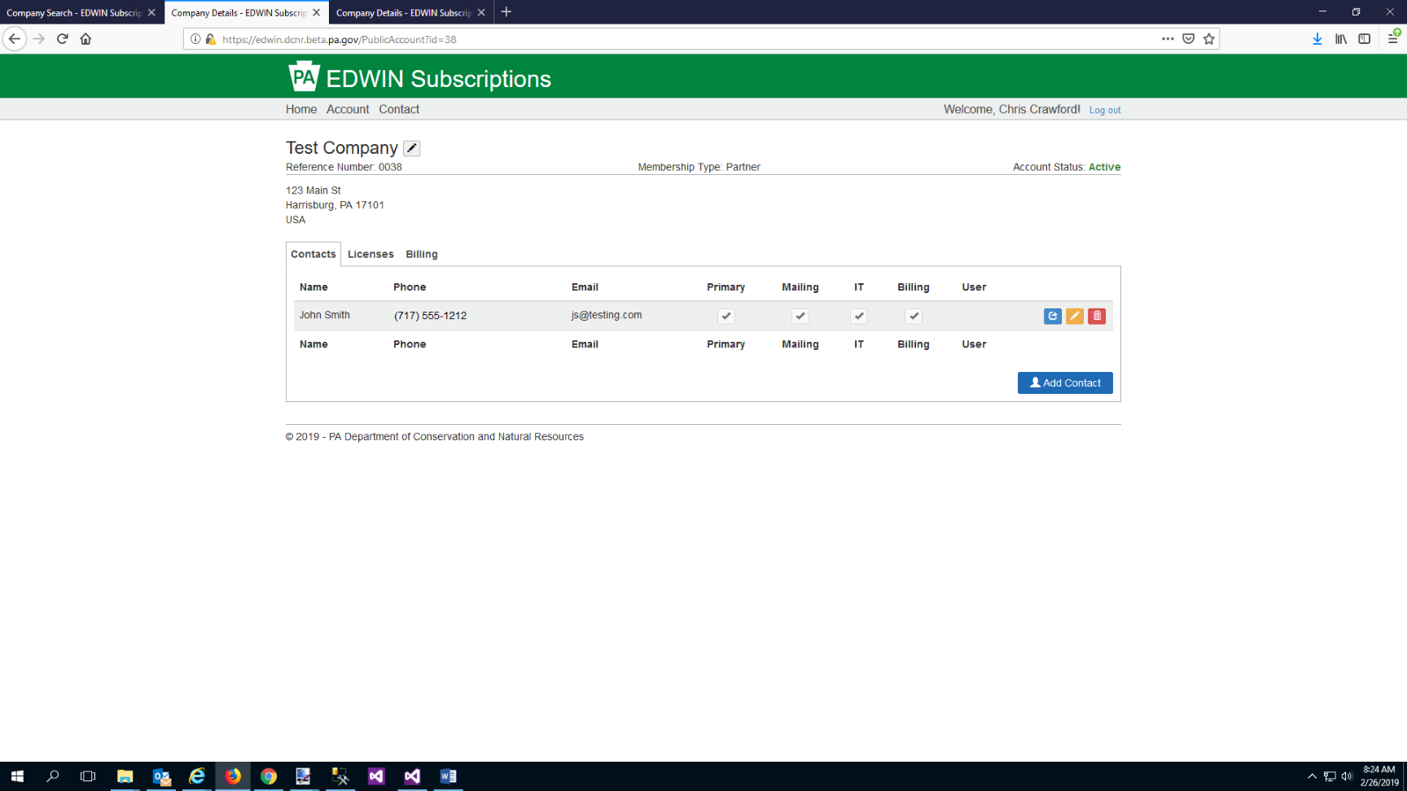

Editing Company Details
1. On your Account page, click the pencil icon next to your company name.
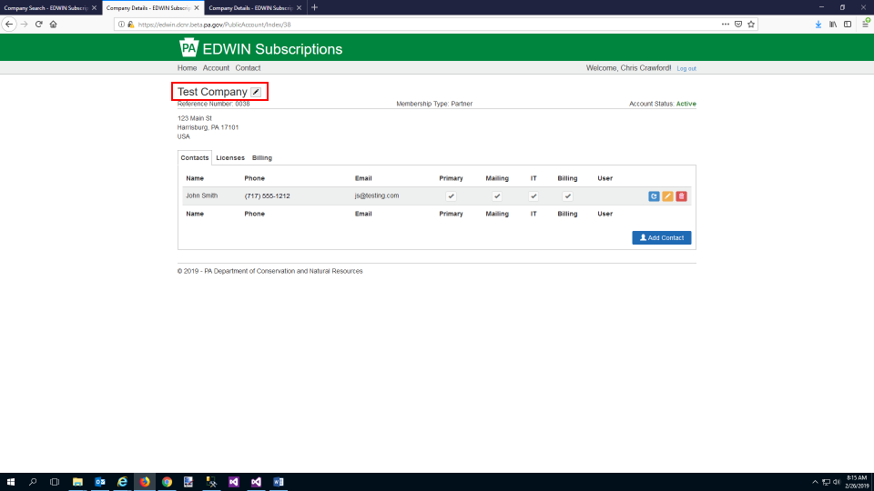
2. Edit/Change any Company information and then click the “Save” button.
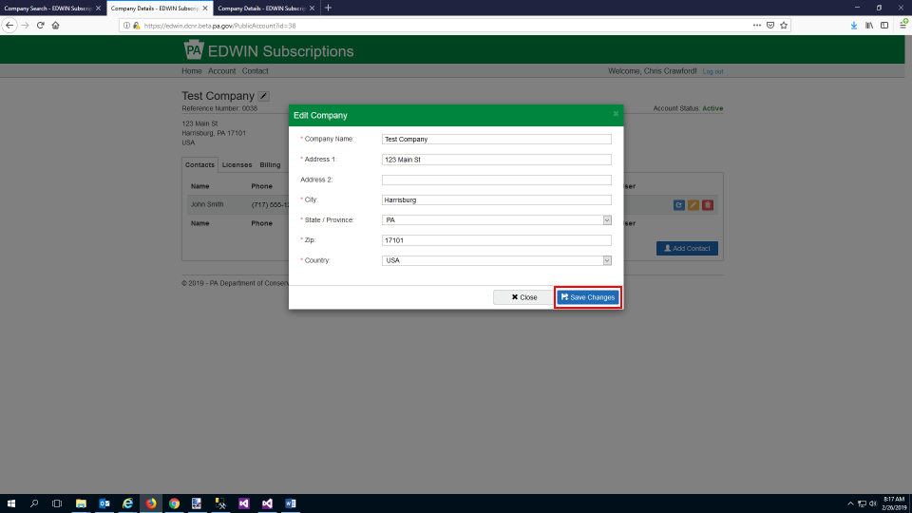
Adding New Contact
1. On your Account page, navigate to the “Contacts” tab and click the “Add Contact” button.
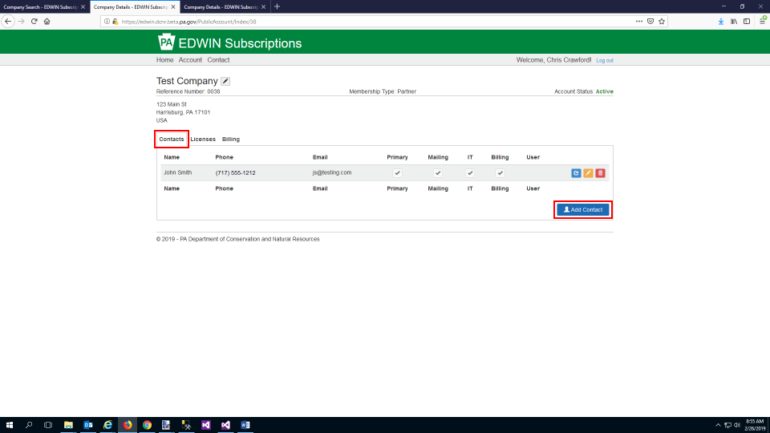
2. Enter the Contact’s info and select which type(s) of contact they should be listed as. If you wish to allow this contact to log in to the system and manage this account then click the “Yes” radio button under “Account Management.” Click the “Save Contact” button.
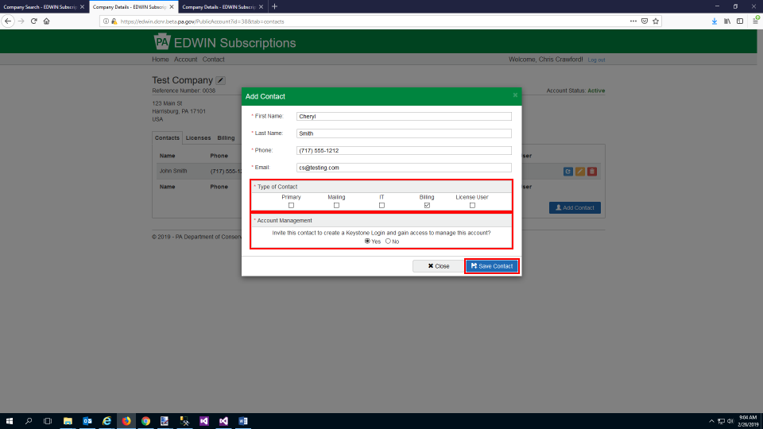
3. If you selected “Yes” under Account Management then the new Contact will receive an email at the email address you provided with instructions for registering and gaining access to the EDWIN Subscriptions Management System account. The instructions for completing those steps can be found HERE.
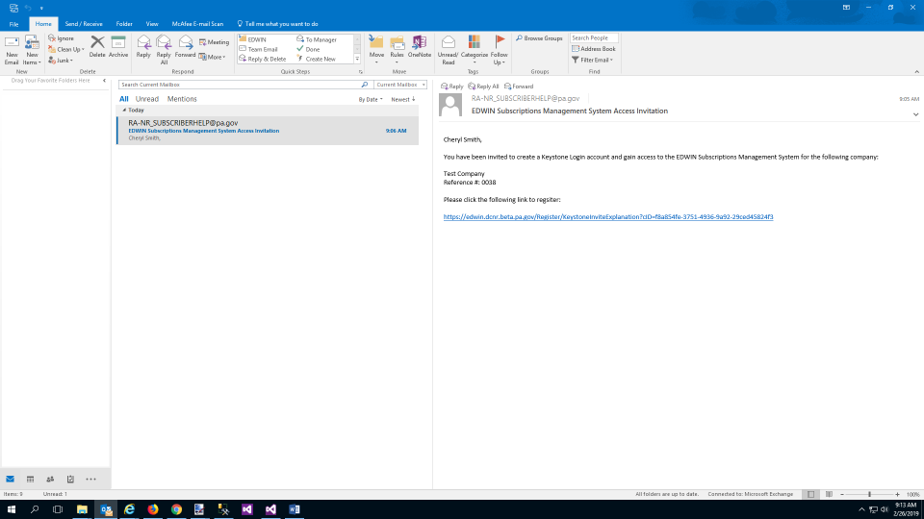

Granting Existing Contact Access
1. On the “Contacts” tab, click the blue “Invite” button in the row of the Contact that you want to give access.
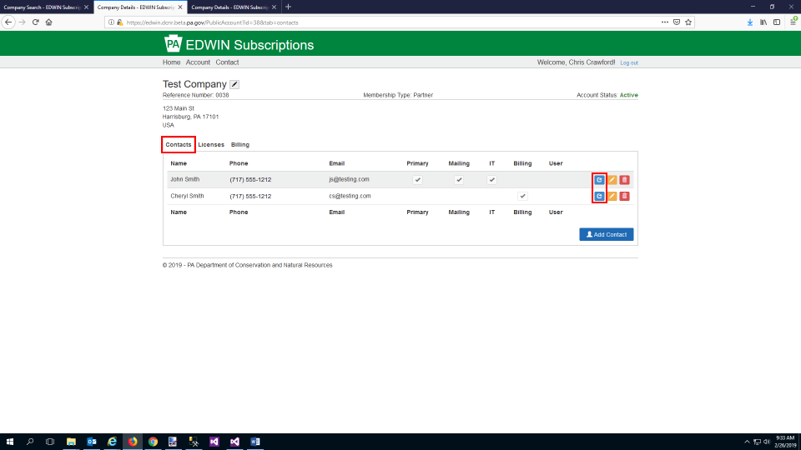
2. You will get a confirmation page making sure you want to grant this Contact access. Click the “Invite” button to confirm.
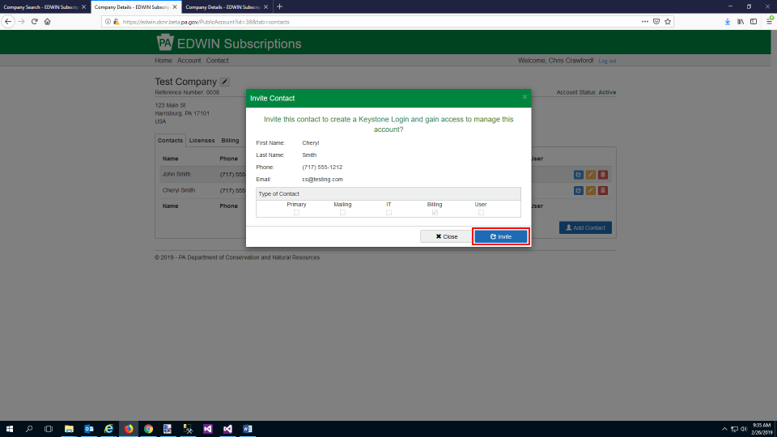
3. The Contact will receive an email at the email address on file with instructions for registering and gaining access to the EDWIN Subscriptions Management System account. The instructions for completing those steps can be found HERE.

Editing Contacts
1. On the “Contacts” tab, click the yellow “Edit” button in the row of the Contact that you want to edit.
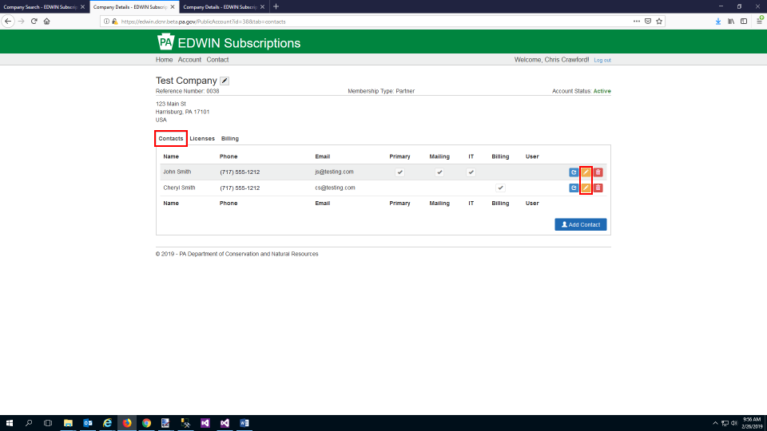
2. Update the Contact’s Info and then click the “Save changes” button.
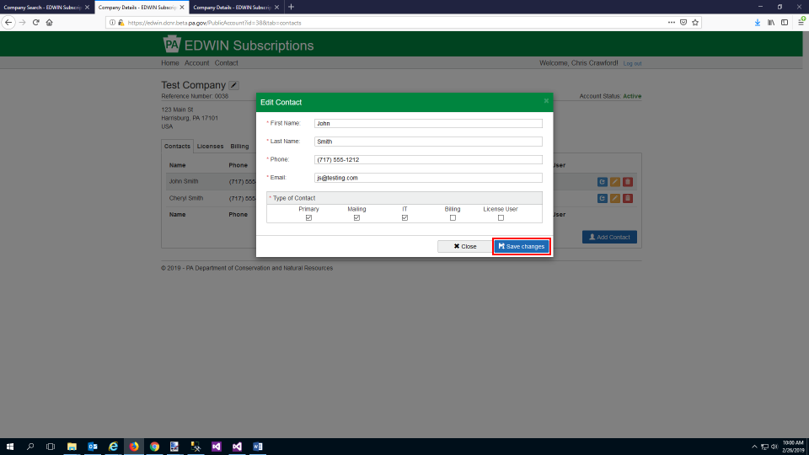

Deleting Contacts
1. On the “Contacts” tab, click the red “Delete” button in the row of the Contact that you want to delete.
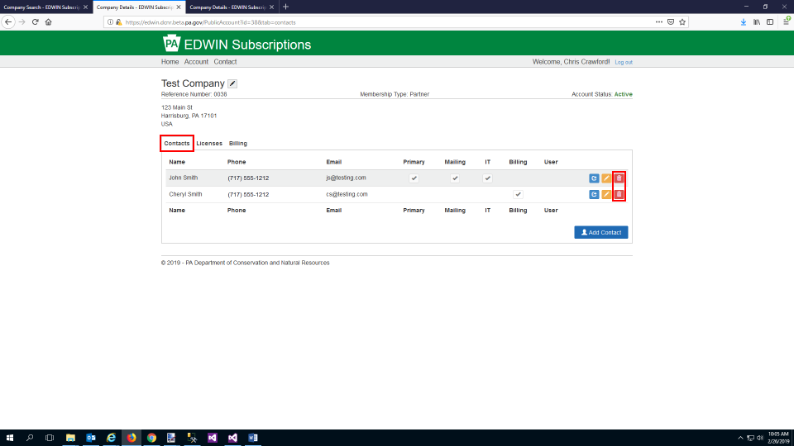
2. You will see a confirmation page, asking if you are sure you want to delete this contact. Click the red “Delete” button to remove the contact. Note: Deleting the contact will remove their ability to access the EDWIN Subscriptions Management System if they have access.
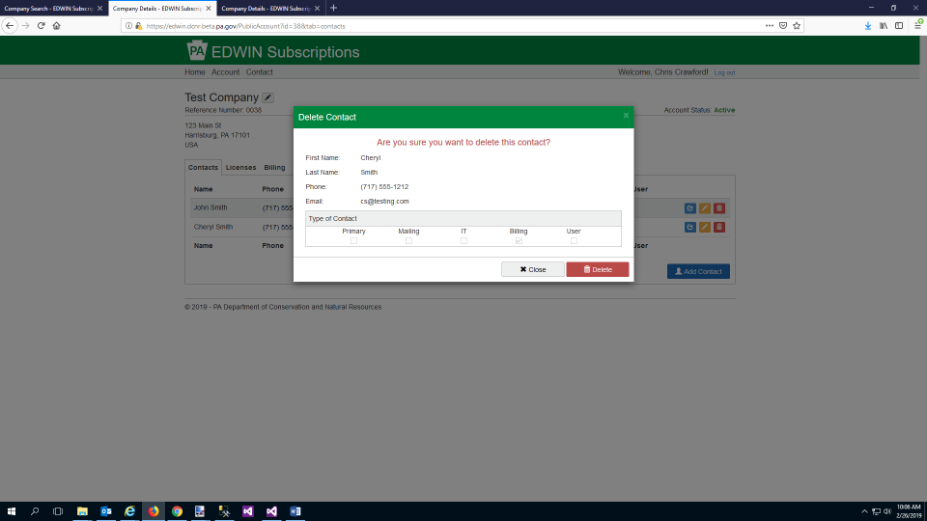
View EDWIN License Details
1. Click on the “License” tab. Here you can see info for each of your EDWIN Subscriptions such as the License ID, Subscription Year, the Username for logging into EDWIN, and License Status.
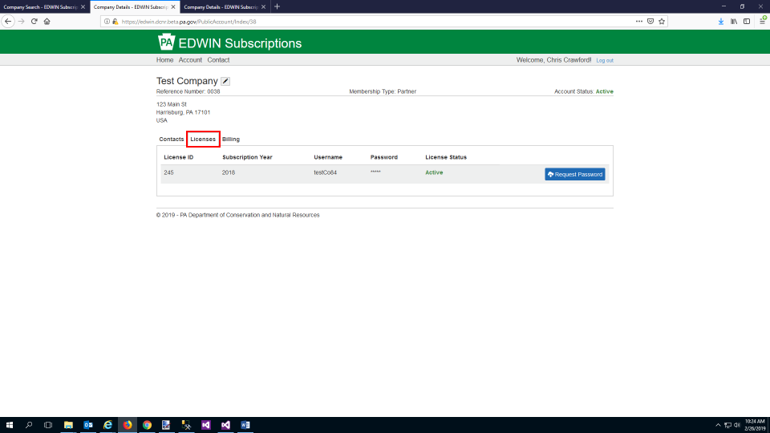

Requesting EDWIN License Password
1. On the “Licenses” tab, click the “Request Password” button in the row of the License that you want the password for.
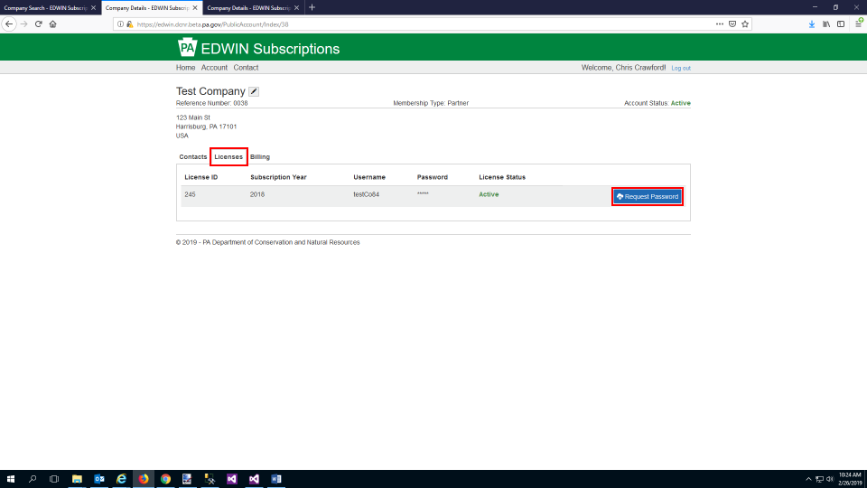
2. You will see a confirmation screen making sure that you want to request this password. Click the “Request” button.
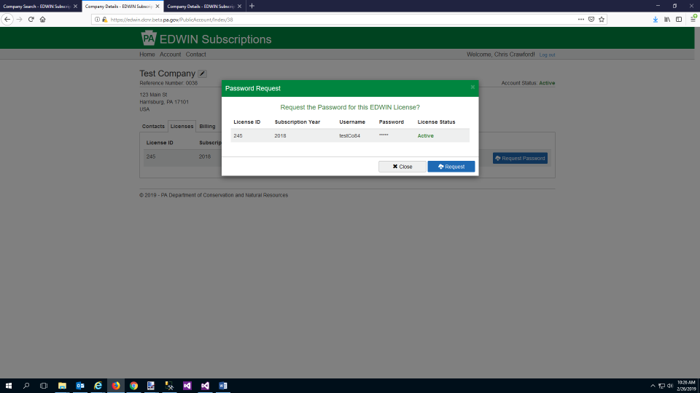

3. You will see a notification screen letting you know that your request has been sent. System Administrators will be notified of your request and follow up with you to provide the password.
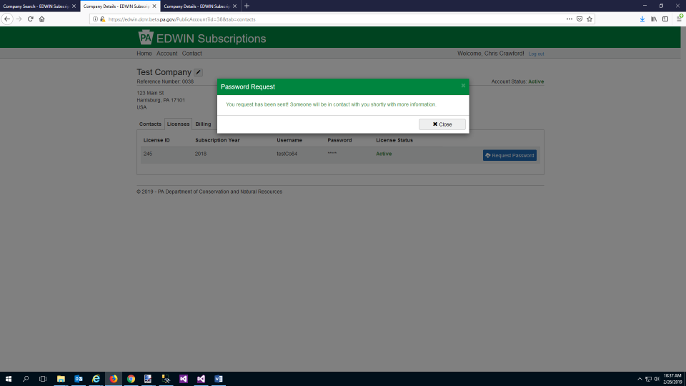

Submitting Payment
1. Log in to the system and navigate to your Account page. Click the green “Add/Renew License” button in the top right.
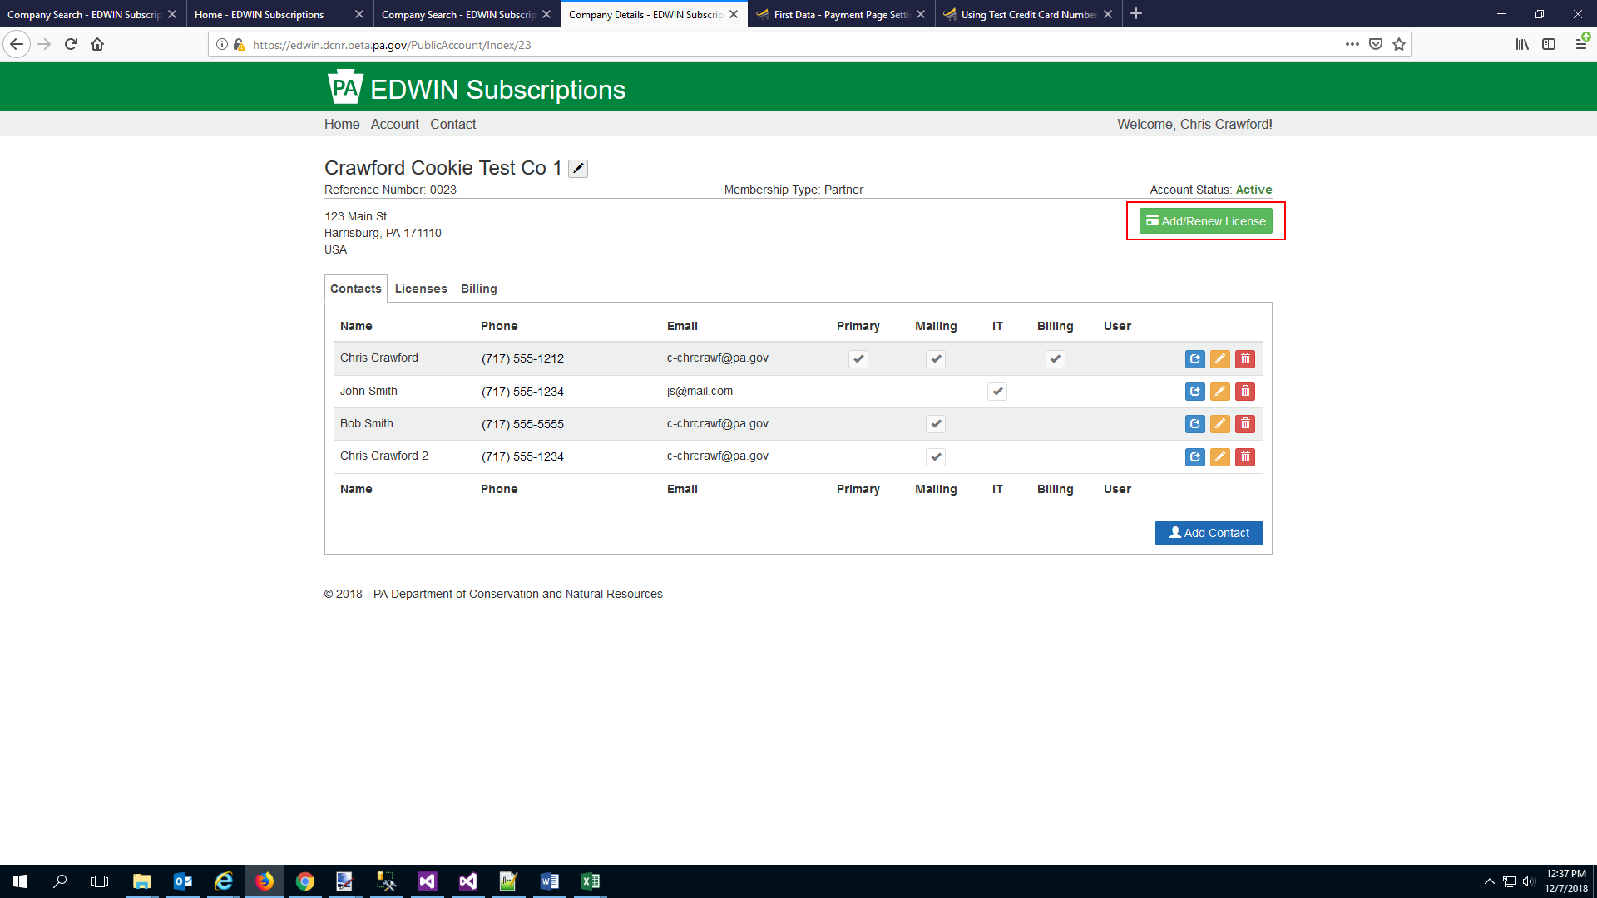
2. Select the number of new licenses that you want to add and check/uncheck the license(s) that you want to renew. Click the blue “Make Payment” button once you are ready.
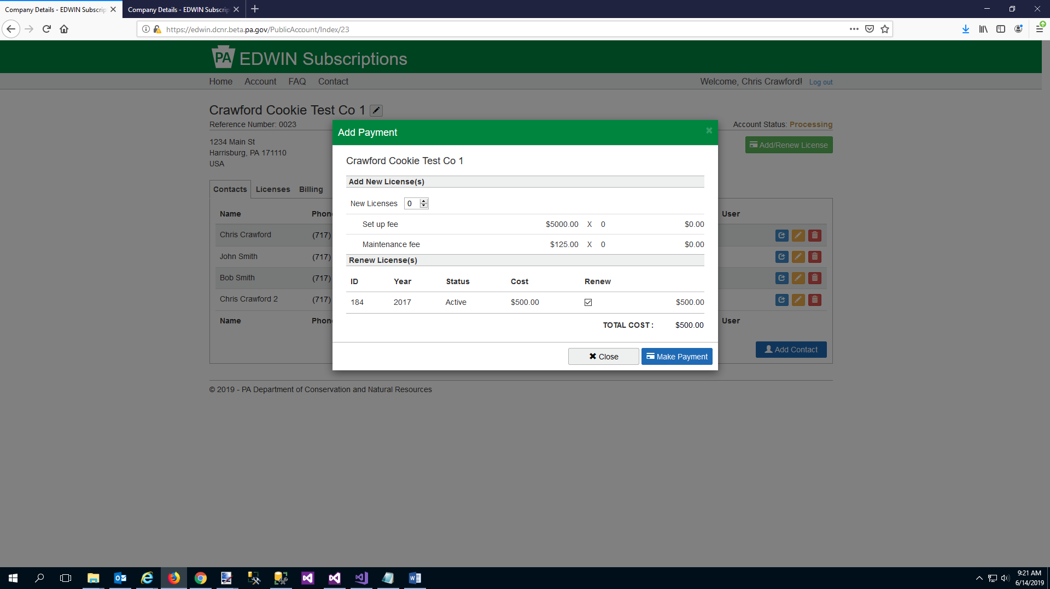
3. Select whether you want to pay by e-check or credit card then fill out the payment processor’s form. Once all fields are filled out submit your payment to complete your purchase.
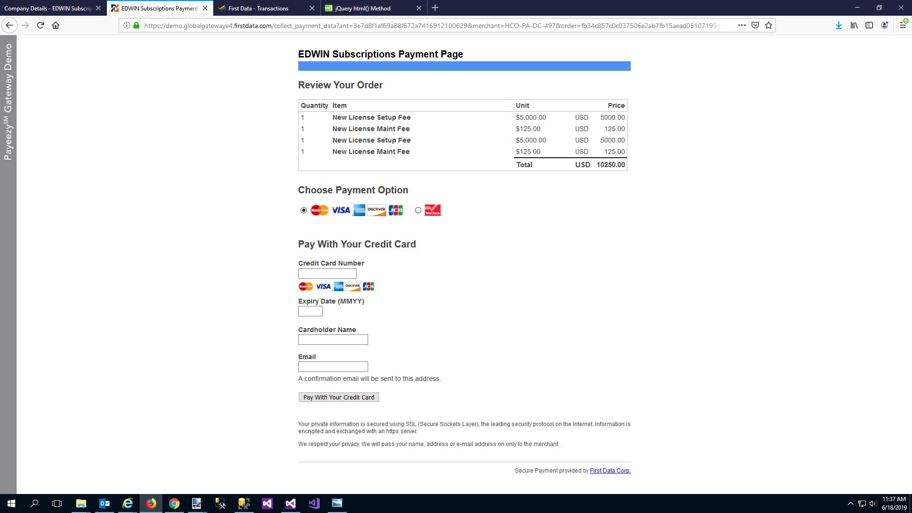
4. You will be redirected back to the EDWIN Subscriptions system. A success page will be displayed showing each of your billing line items. You will also receive an email from the payment processor confirming your payment.
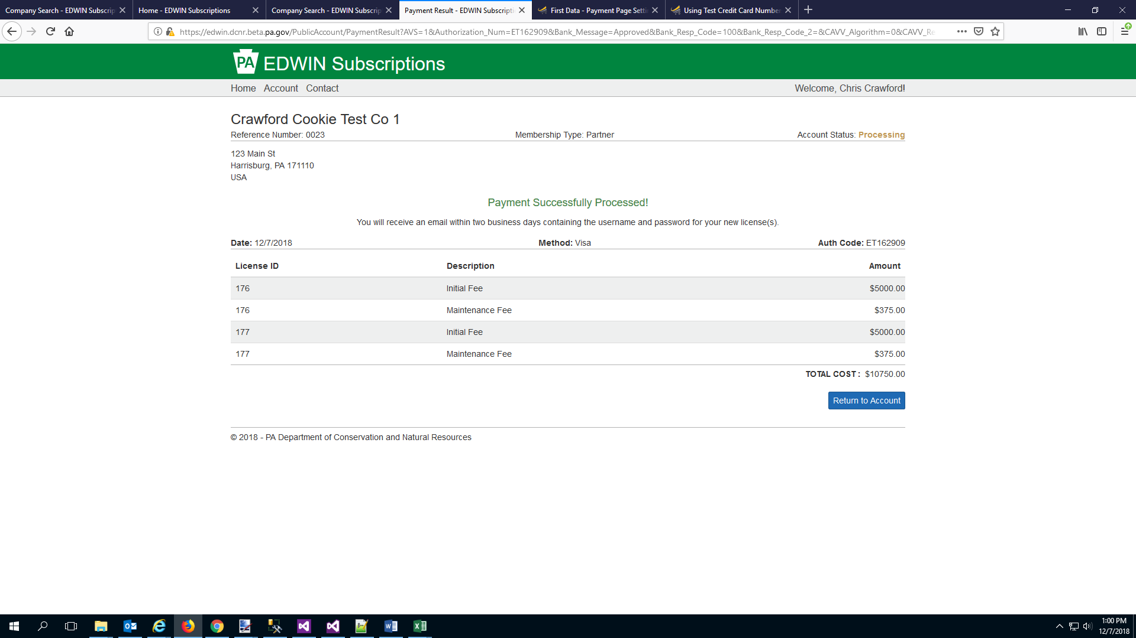
View Billing Details
1. On the “Billing” tab, click the “View Details” button in the row of the payment that you want to view the details for.
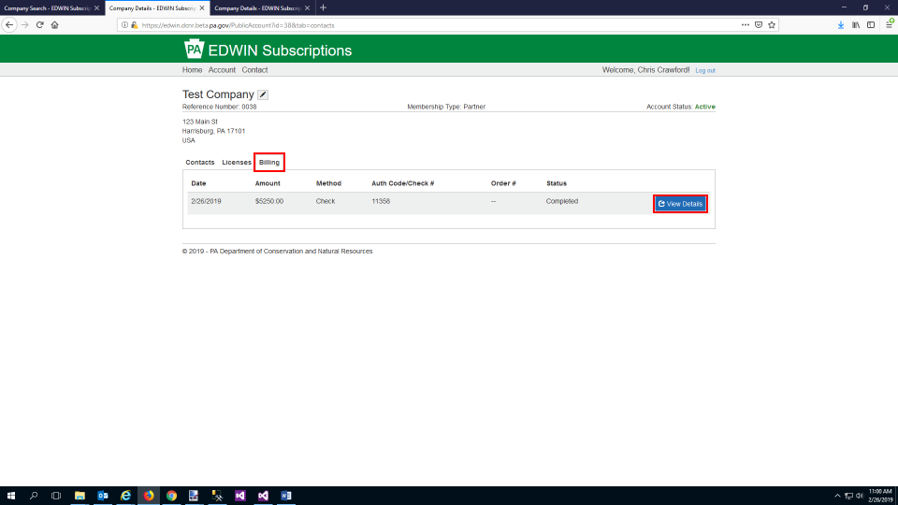
2. A screen will be displayed detailing the charges associated with this payment.
